JAVA SCRIPT….

JavaScript is a scripting or programming language that allows you to implement complex features on web pages — every time a web page does more than just sit there and display static information for you to look at — displaying timely content updates, interactive maps, animated 2D/3D graphics, scrolling video jukeboxes, etc. — you can bet that JavaScript is probably involved. It is the third layer of the layer cake of standard web technologies, two of which (HTML and CSS) we have covered in much more detail in other parts of the Learning Area.

**WEB DEVELOPMENT FOOT STEPS :**

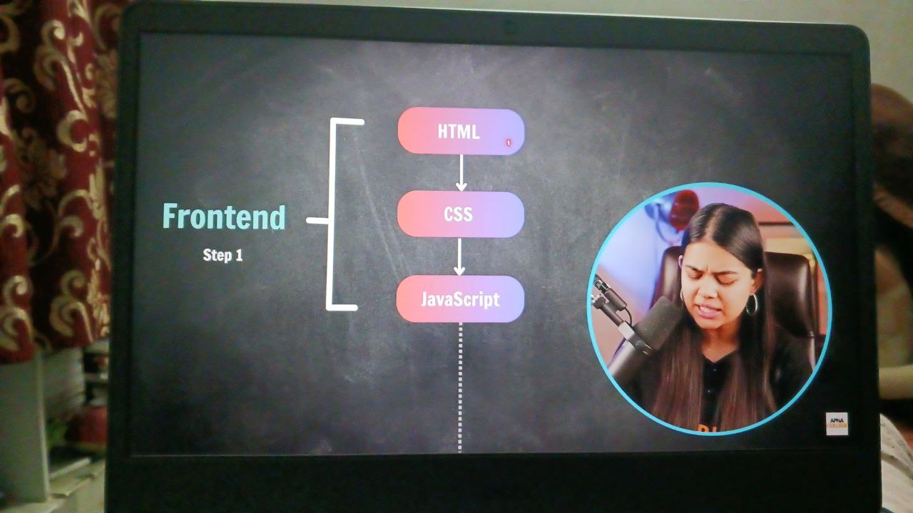

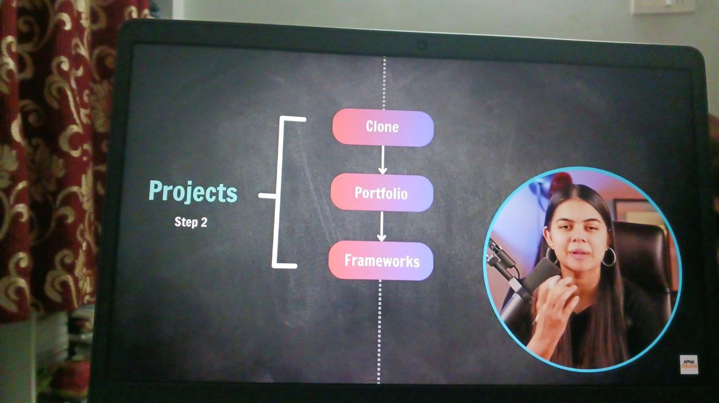

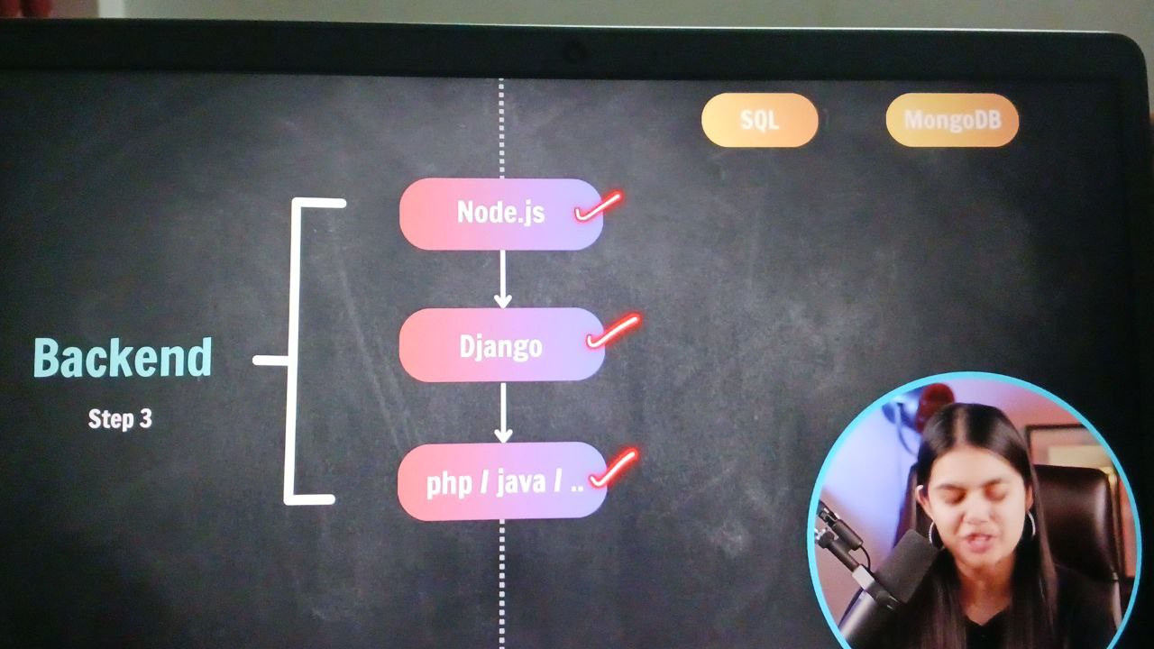

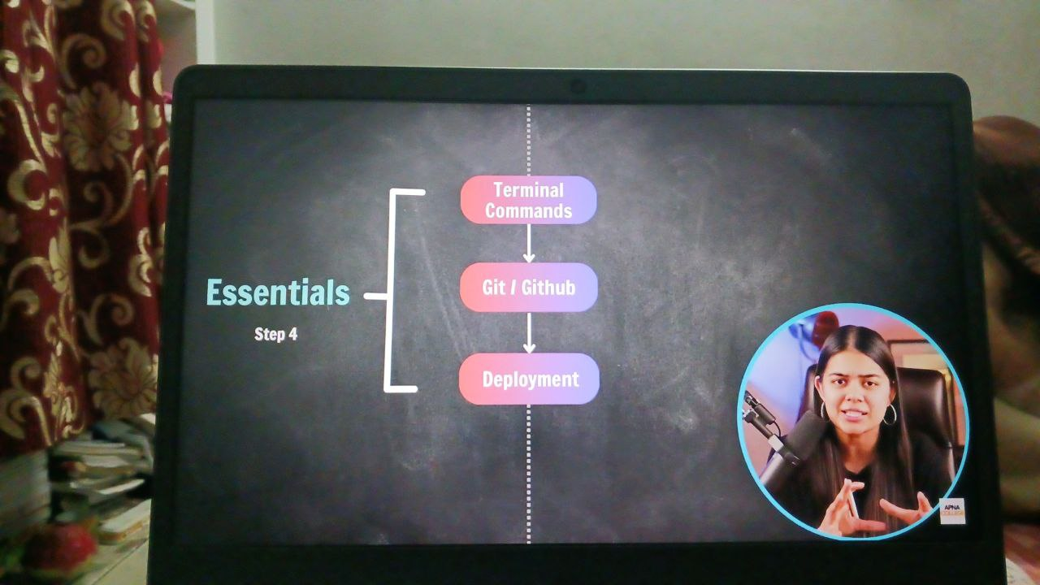

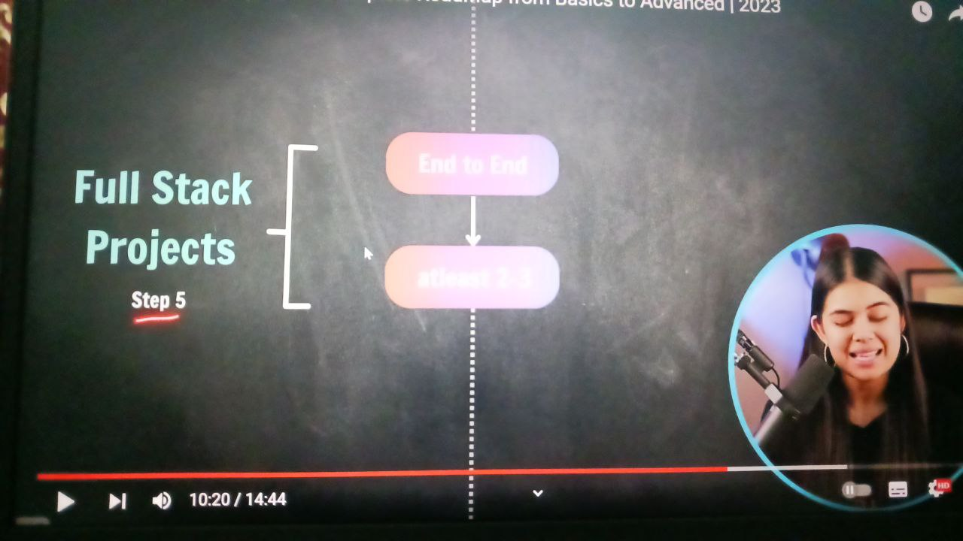

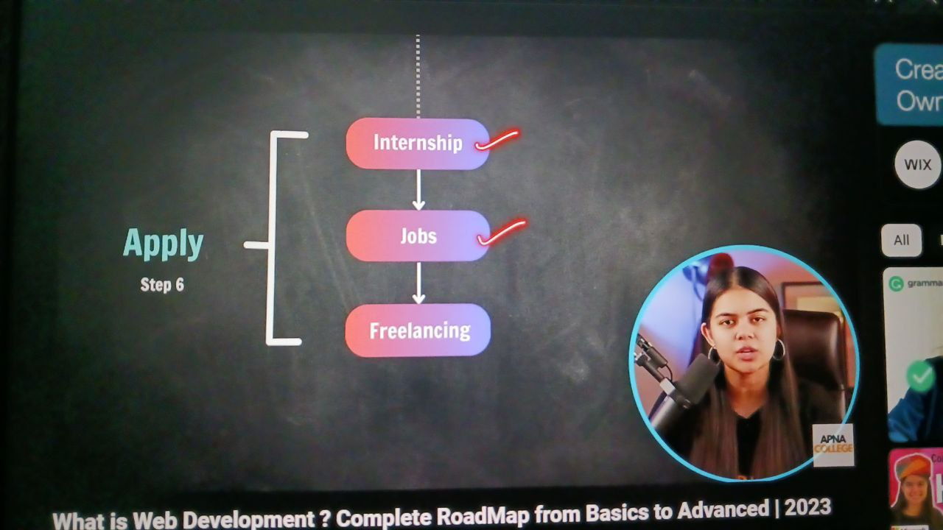

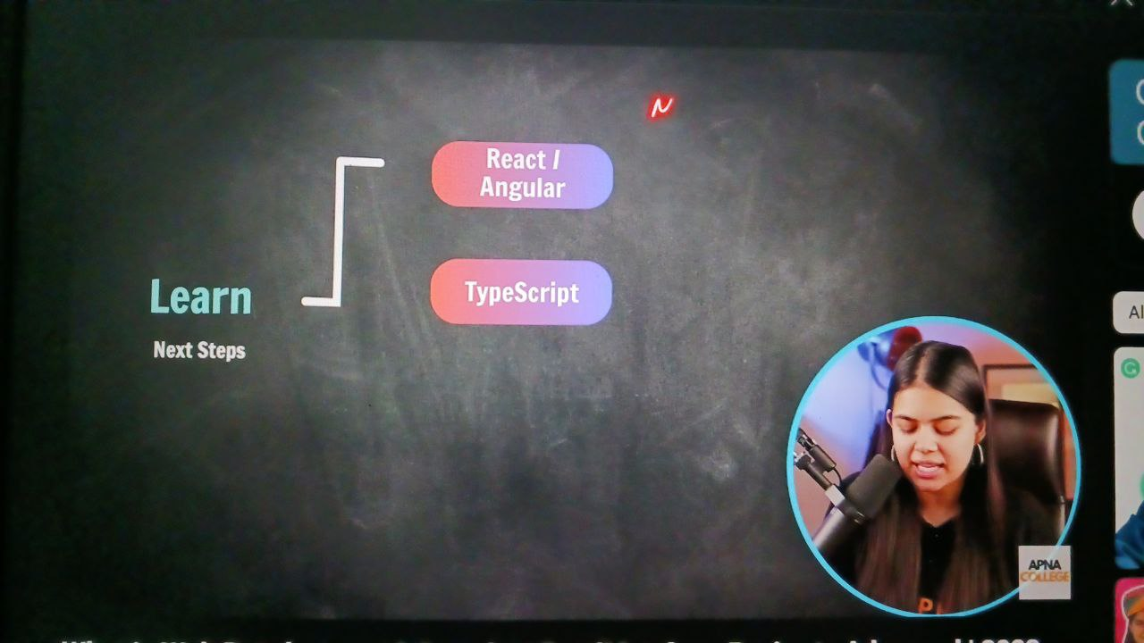

THIS IS THE YOUTUBE LINK OF THE WEB DEVELOPMENT ROAD MAP (https:// [www.youtube.com/watch?v=z0n1aQ3IxWI](http://www.youtube.com/watch?v=z0n1aQ3IxWI))

First class of JS :

console.log("Welcome to Apna college!");

console.log("TULASI");

console.log("i love js");

javaScript is a dynamically typed language (there is no need of initialising the data type of the variable like python)

fullname="tulasi";

age = 24;

price = 99.99;

x = null;

y = undefined;

console.log(x);

console.log(y);

console.log(typeof age);

output:

null

undefined

number

//Boolean operator:

isfollow = false;

console.log(isfollow);

console.log(typeof idfollow);

output:

false

Boolean

// = is assignment operator ,variable name can be any thing

//VARIABLES : 1- case sensitive(a,A are different)

          //  2-only letters ,digits,underscore(-),$ sign is allowed(not even space,(@))(full nameX(no))

          //  3-first letter should be a letter , _ ,$,should not start with numbers

          //  4-reserved words cannot be varable names Ex: console.

/**cases : fullName-camel case*

          fullname-X

          full_name-snakecase

          full-name-kebab

          FullName-pascalcase  **/

/* let,const & var(2015)

     ES6 came after 2015 so we use let,const

    -> In var varable can be redeclared ->global scope

    -> In let we cannot redeclared and can update->block scope

    -> In const we cannot redeclare or cannot update (can be written in capital letters)->block scope*/

let a;

console.log(a);//undefined

const b=0;

console.log(b);//error( in const the varable should be defined other wise it gives error)

{// a is different in both the blocks

    let a=2;

    console.log(a);

}

{

    let a=5;

    console.log(a);

}

Data types in JS:

// Data Types

// Number,String, Boolean, Undefines, Null, BigInt , Symbol

//primitive(7)    non_primitive(objects)

There are two different data types

* Primitive(number, string, Boolean, undefined , null, BigInt , symbol)
* Non-primitive(objects)

PRIMITIVE:

//number

/*let age = 6;

let price=100.50;*/

* //string
* /* let fullname="TULASI NALLURI"; */
* //boolean
* //isFollow=true;
* //undefined
* //let x;//
* //null
* //let n=null;  (absence of object)
* //bigInt
* let x=BigInt("123");
* let y=Symbol("Hello!");
* console.log(y);
* console.log(typeof y);

output:

symbole(Hello!)

symbol.

NON-PRIMITIVE: (object) 😊

//collection of variables.

//we can update the values of the object in the const unlike other individual variables

const student ={

    fullname :"Tulasi",

    age : 20,

    cgpa : 9.3,

    ispass : true,

};

// updating the values of the objects

student["age"]=student["age"]+1;

console.log(student["age"]);

student["fullname"]="TULASI NALLURI";

console.log(student.fullname);

//console.log(student["age"]);

const product={

    fullname:"Parker Jotter Standard CT Ball Pen",

    rating:4.5,

    offer:20,

    price:270,

};

console.log(product)

const profile ={

    username:"ShradhaKhapra",

    followers:"569K",

    following:4,

    noofpost:195,

    isFollow:false,

};

console.log(profile);

//console.log(typeof profile);

console.log(typeof profile["username"]);

COMMENTS IN JS:

//comment are written by these to//

/* or by this */

OPERATIONS IN JS:

  arthmetic operator*/

 let a=5;

 let b=2;

console.log(a-b);

console.log(a+b);

console.log(a/b);

console.log(a*b);

// //modulus

console.log("a%b = ",a%b);

// //exponentiation

console.log("a**b =",a**b);

// //increment(unary operator)

console.log("a++ = ",a++);

// //decrement

console.log("b-- = ",b--);

//a++(post increment),++a(pre incement)

let a=5;

let b=2;

console.log("a = ",a);//5

console.log("a++ = ",a++);//5

console.log("a = ",a);//6

console.log("++a = ",++a);//7

//assigment operator =,+=,-=,/=,*=

//comparision operators ==,!=,===(equal to & type),!==,>,<,<=,>=

// //returns boolean value.

let a=5;

let b=5;

let c="5";

console.log(a!=b);

console.log(a==b);

console.log(a>=b);

console.log(a<=b);

//first js convert string to a number and them compare them.

console.log("in string",a==c);//ture

console.log("===",a===c);//false(because in === it is different from number and the string so it gives false

// console.log("!==",a!==c);

//logical operators &&,||,!

//returns boolean value

let a=7;

let b=5;

let cond1 = a>b;

let cond2 = a==6;

console.log(cond1 && cond2);

console.log(cond1 || cond2);

console.log(!cond1);//logical not(true=false)

CONDITIONAL STATEMENTS IN JS:

//conditional statements.

//if statement

if(age>18){

    console.log("eligible to vote");

}

else{

    console.log("not eligible to vote");

}

alert("hello world");//popup

//Practice Qs1 - js program

//user defined

let name=prompt("enter a number");

if(name%5===0){

console.log(name,"yes it is a 5 multile");}

else{

    console.log(name,"not a 5 multiple")

}

//Practice Qs2 - js program

let marks=prompt("enter your marks");

let grade;

if(marks>=80&&marks<=100)

{

   grade="A";

}

else if(marks>=70&&marks<=79)

{

    grade="B";

}

else if(marks>=60&&marks<=69)

{

    grade=C;

}

else if(marks>=50&&marks<=59)

{

    grade=D;

}

else

{

    grade=F;

}

console.log(grade);

FOR-IN-LOOP: (used for objects)

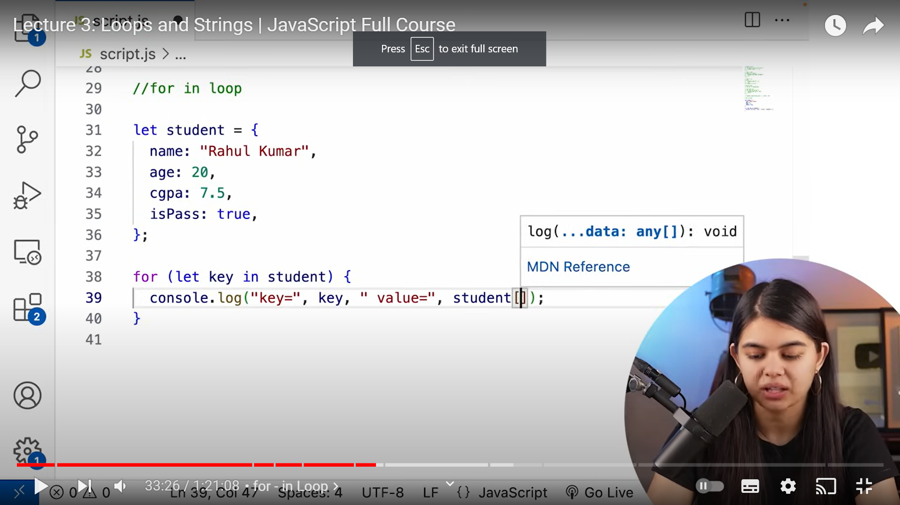

FOR-OF-LOOP: (used in strings)

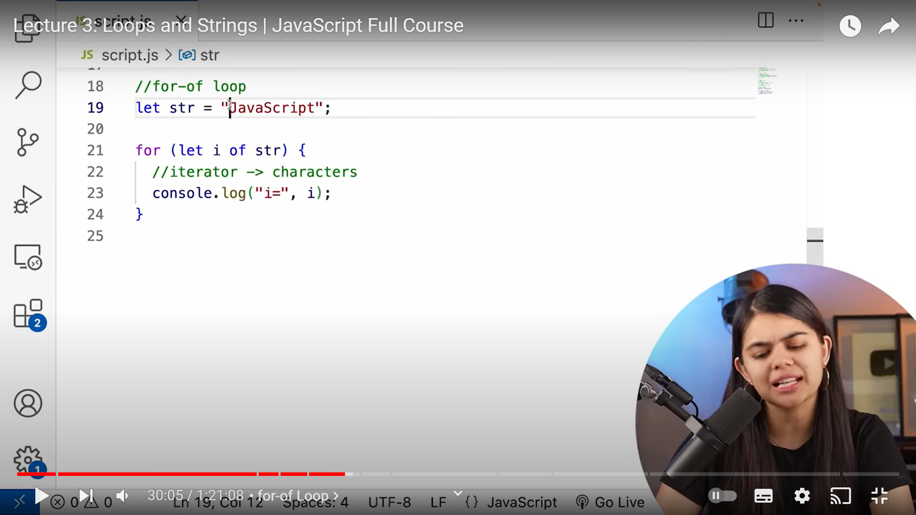

LOOPS IN JS 😊:

//loops

//calculate sum of first n numbers

let sum=0;

let n=100;

for(let i=1;i<=n;i++)

{

    sum+=i;

}

console.log("the value is ",sum);

for(var i=1;i<=5;i++)this is a global variable so the print statement will give the output 6

{

    console.log(i);

}

console.log(i);

for(let i=1;i<=5;i++)where as here it shows that i is not defined because we used let so i became the block variable.

{

    console.log(i);

}

console.log(i);

//while loop.

let n=5;

while(n>0){

    console.log(n);

    n--;

}

do{

    console.log(n)

    n--;

}while(n>0);

//for-of loop;(it help to iterate on some special datatypes.)

let str="tulasi";

let size =0;

for(let i of str)//iterator->charecter.

{

    console.log(i);

    size++;

}

console.log(size);

//for_in loop.

let student ={

    name:"Tulasi",

    age:20,

    cgpa:7.5,

    ispass:true,

};

for(let key in student)

{

    console.log(key,"= key","value =",student[key]);

}

//practice QS1 -js

 let n=100;

for(let i=0;i<=n;i++)

{

    if(i%2!==0)

    {

        console.log(i);

    }

}

GAME PROBLEM😊:

//practice QS2 -js

let game=25;

let usernum = prompt("guess the game number");

while(usernum!=game)

{

   usernum = prompt("you enter the wrong number . guess again : ");

}

console.log("congratulations you enterd the right number");

console.log(typeof game);

STRINGS IN JS😊 :

Strings are the sequence of characters used to represent text.

Create string:

Let str=”tulasi”;

String length:

Str.length

String indices:

Str[0],str[1],str[2].

//strings

let str="apna clg";

let str1='tulasi';

console.log(str1.length);

console.log(str[0]);

TEMPLATE LITERAL IN J😊:

A way to have embedded expressions in strings.

` this is a template literal`

String interpolation:

To create string by doing substitution of place holders

Syntax:

`string text ${expression} string text`.

//template litrals

let str2 ="apna clg";

console.log(str[8]);

let specialString=`this is a template literal`;

let letter=` the 6th letter od str[6] is ${str[6]}`;

console.log(letter);

output:

the 6th letter od str[6 ] is l

ESCAPE CHARACTERS:

Console.log(“apna college”):

//if we want to print the ‘apna’ in one line and ‘college’ in one lone we can write

Console.log(“Apna\ncollege”);

//escape characters

console.log("apna\ncollege");//next line

console.log("apna\tcollege");//tab space

let str3="apna\tcollege";

console.log(str3.length)//we expect it to be 13 but it give 12

//because in JS the escape characters are considered as one character

STRING METHODS/FUNCTIONS IN JS😊:

These are built-in functions to manipulate a string.

* Str.toUpperCase()
* Str.toLowerCase()
* Str.trim()//remove white spaces.

let str="   NtuL asi   ";

console.log(str.toUpperCase());

console.log(str.toLowerCase());

console.log(str.trim());//starting and ending spaces (removing)

